Deploying a Wikimedia application into the AWS Cloud

1. I am suggesting by using the AWS Code Pipeline the deployment process for the application for Wikimedia.
2. Components to used
3. Github as a version control OR
4. AWS Codecommit for the Version Control
5. AWS CodeBuild
6. Code Pipeline
7. ECR
8. ECS
9. CloudWatch
10. SNS
11. Terraform
12. S3

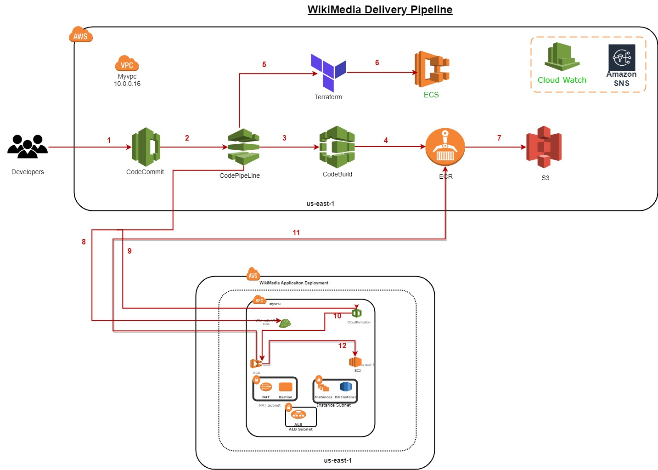

Steps to the process.

1. In the above mentioned diagram the process will start from the pushing code to the code repository i.e CodeCommit.
2. Once codecommit gets the latest code the Code pipeline will get trigger and will start the build.
3. In the CodeBuild job the process will starts and build the image.
4. Build image will gets push into the ECR.
5. Terraform code which is to build the complete infra to gets created.
6. Deploy the code application into ECS.
7. S3 for image artifactory store.
8. Code Pipeline process triggers and necessary components get created in the AWS account.
9. SNS been used during the Code Pipeline process to push the notifications alerts to based on the topic.

10. Required components gets created using by the CFT template.

11.Using the CFT stack ECS configuration gets created.

12.This is the step where image gets pull from the ECR to deploy it

into the ECS cluster.

13.Connectivity between RDS instance to ECS cluster.

And as shown in the diagram RDS instance there is a NAT gateway and bastian host.

Using bastian host we can connect the private instance where mysql client has installed.

Application load balancer to access the dns domain name to access globally.

To access the ECS Cluster logs Cloudwatch logs group can be created and can be attach that group to the container logs.

Logs can be pushed based on the application behavior.